**Test Report**

**Acceptance Testing – in Gherkin :**

Using the Cucumber's Gherkin format to write the acceptance tests for the given story.

***The Below Gherkins will cover all the test scenarios. But Below these I have illustrated the total Scenarios to be tested in High level Gherkins***

**Feature:** Payroll report with dates of Sales staff salaries and bonuses

**Background:** As a payroll accountant user, will receive the report file to verify the salary and bonuses pay dates

**Given** user logged in as a payroll accountant user  
**And** user has received report file with dates of salaries and bonuses need to be paid.

**Scenario Outline:** Verifying that salary pay day is the day before the last weekend date if pay date is weekend(Sunday or Saturday)

**When** <lastday> of the <month> is <weekend day>

**Then** Pay the salary on salaryPayDay of the <month>

**Examples:**

| lastday | month | weekend day |

| 31 | January | Saturday |

| 28 | February | Sunday |

| 31 | March | Saturday |

| 30 | April | Sunday |

| 31 | May | Saturday |

| 30 | June | Sunday |

| 31 | July | Saturday |

| 31 | August | Sunday |

| 30 | September | Saturday |

| 31 | October | Sunday |

| 30 | November | Saturday |

| 31 | December | Sunday |

**Step Definitions behind the Gherkins:**

Calculate the salaryPayDay basing on the Weekend day by case method

match <weekend day> {

Case "Saturday" { salaryPayDay = lastday - 1 }

Case "Sunday" { salaryPayDay = lastday - 2 }

}

**Scenario Outline:** Verifying that bonus day is 15th of every month if that month 15th day is not weekend

**When** 15th of the <month> is not <weekend day>

**Then** Pay the bonus on bonusPayDay of the <month>

# **Examples:**

| month | weekend day |

| January | Saturday |

| February | Sunday |

| March | Saturday |

| April | Sunday |

| May | Saturday |

| June | Sunday |

| July | Saturday |

| August | Sunday |

| September | Saturday |

| October | Sunday |

| November | Saturday |

| December | Sunday |

**Step Definitions behind the Gherkins:**

Calculate the bonusPayDay basing on the Weekend day by case method

match <weekend day> {

Case "Saturday" { bonusPayDay = 15+4 }

Case "Sunday" { bonusPayDay = 15+3 }

}

***#################*** ***illustrated the total Scenarios to be tested in High level Gherkins for the above #################***

**Scenario Outline:** Verifying that salary pay day is the day before the last weekend date if pay date is weekend(Sunday or Saturday)

**When** last day of the <month> is weekend(Sunday or Saturday)

**Then** verify the salary pay day of the <month> is the last day before that weekend

**Examples**:

|month|

|January|

|February|

....

|December|

**Scenario Outline:** Verifying that salary pay day is last day of that month if last day of month is not weekend(Sunday or Saturday)

**When** last day of the <month> is not weekend(Sunday or Saturday)

**Then** verify the pay day is the last day of the <month>

**Examples**:

|month|

|January|

|February|

....

|December|

**Scenario Outline:** Verifying that bonus day is 15th of every month if that month 15th day is not weekend

**When** 15th of the <month> is not weekend(Sunday or Saturday)

**Then** verify the bonus pay day on report is the 15th of that <month>

**Examples**:

|month|

|January|

|February|

....

|December|

**Scenario Outline:** Verifying that bonus day is next Wednesday from 15th of that month if 15th day is weekend(Sunday or Saturday)

**When** last day of the <month> is weekend

**Then** verify the pay day is next Wednesday from 15th of that <month>

**Examples**:

|month|

|January|

|February|

....

|December|

**DEFECTS**

**Scenario 2: Bug**

1. Bug: No Validation error message for when the “How much would” is Zero

**Steps to Reproduce:**

1. Open a browser and launch http://www.nationalarchives.gov.uk/currency/results.asp#mid

2.Click on Old money to new tab

3. Enter Zero in ““How much would” £ , s, d – Fields from “Find out how much yesterday's (1270-1970) money was worth in 2005.” Section

4.Select a year from the “select a year” drop box

5. Click on Convert

Expected: “select a year” still should be there

Actual: No Validation message is displayed.

2. Bug: “select a year” is replace with the selected year after the Conversion

**Steps to Reproduce:**

1. Open a browser and launch [http://www.nationalarchives.gov.uk/currency/results.asp#mid](http://www.nationalarchives.gov.uk/currency/results.asp" \l "mid)

2. Click on Old money to new tab

3. Enter some values in ““How much would” £ , s, d – Fields from “Find out how much yesterday's (1270-1970) money was worth in 2005.” Section

4. Select a year from the “select a year” drop box

5. Click on Convert

6. Check the Drop down for “select a year” text / item.

Expected: “select a year” still should be there

Actual: select a year” is replace with the selected year after the Conversion

3. Observation: Year Drop box has got 5yrs gap for 19th Century ( 1900, 1905, 1910, 1915...) where as other centuries has for 10 yrs gap ( 1700, 1710, 1720 …) from “Find out how much yesterday's (1270-1970) money was worth in 2005.” Section

4. Bug : select a year form “Find out how much yesterday's (1971-2005) money was worth in 2005.” is missing 1971 value/item as this is supposed to start from 1971 but it is started with 1975

**Steps to Reproduce:**

1. Open a browser and launch http://www.nationalarchives.gov.uk/currency/results.asp#mid

2. Click on Old money to new tab

3. check the year starting value is 1971 from Select a year drop down from form “Find out how much yesterday's (1971-2005) money was worth in 2005.” section.

Expected: Select a year value should start 1971

Actual : select a year form “Find out how much yesterday's (1971-2005) money was worth in 2005.” is missing 1971 value/item as this is supposed to start from 1971 but it is started with 1975

5. Bug: “select a year” is replace with the selected year after the Conversion

**Steps to Reproduce:**

1. Open a browser and launch [http://www.nationalarchives.gov.uk/currency/results.asp#mid](http://www.nationalarchives.gov.uk/currency/results.asp" \l "mid)

2. Click on Old money to new tab

3. Enter some values in ““How much would” £ – Fields form “Find out how much yesterday's (1971-2005) money was worth in 2005.” section

4. Select a year from the “select a year” drop box

5. Click on Convert

6. Check the Drop down for “select a year” text / item.

Expected: “select a year” still should be there

Actual**:** select a year” is replace with the selected year after the Conversion

6. Bug : Validation is missing on "Find out how much yesterday's (1971-2005) money was worth in 2005." section.

**Steps to Reproduce:**

1. User navigated to Old money to new section in given link "http://www.nationalarchives.gov.uk/currency/default0.asp#mid"

2. User enters pound value as 1.00 into “How much would” field and selected the year from the “Find out how much yesterday's (1971-2005) money was worth in 2005” section.

3. And user clicked on Convert button

4. User has taken into result screen and displayed the proper result value with text format as

“In 1975, £1.00 would have the same spending worth of 2005's **£5.57**”. And also displayed with editable fields “How much would” field and year dropdown.

5. User again enters negative(-1) or non numeric (abc)numbers into “How much would” field and selected the year dropdown from result page.

6. User clicked on Convert button .

Expected**:**  Error message didn’t display to the user and returned the results for this invalid input – “In 1975, £-1.00 would have the same spending worth of 2005's **£-5.57**” or “In 1975, £ would have the same spending worth of 2005's **£0.00**” (Added the screenshot below fyi...)

Actual User should be displayed with error alert message.

**Screenshot:**

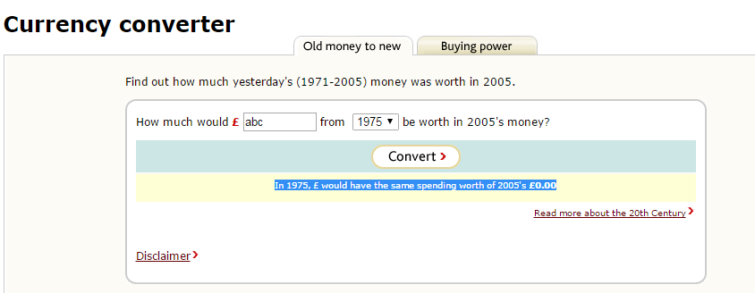

**Questions to be asked**

Question 1: Can we count the Day before Weekend as Salary pay day if that is a bank Holiday?

Question 2: How can take the Months in count is financial Year or Jan -Dec?

**Exploratory Testing**

1. As part of Exploratory Testing I have done below for all the Input Fields

- Boundary Value Analysis ( Min, Min-1, Min+1, Max, Max+1, Max-1)

- Equivalence Class Patrician( Valid[numeric], Not Valid[non numeric])

2. I have tested the UI Testing for all the Browsers ( Chrome, Firefox, Safari, IE)

3. I have tested the Comparability testing for Mobile Emulator within the Browsers using User Agents and Developer tools.